Havering Community Learning Disability Team
Well-being Drop in Sessions

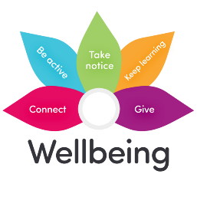 | Looking after your physical and mental health are all part of well-being.
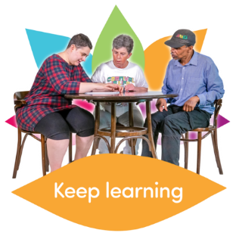 | We are offering drop-in sessions to talk about your well-being.
  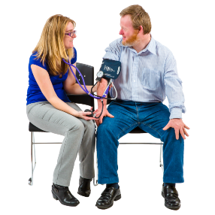 | Come and meet with nurses from the team.  We can support you to think about your well-being.  You can come and ask anything about your health.
 | We can help you with understanding information about your health
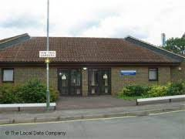 | Sessions will be at The Yew Tree Resource Centre in Romford  20 Yew Tree Gardens  Romford  Essex RM7 9AA
 | Sessions will be on the last Tuesday of the Month (except for December 2026)  From 10:00 – 12:00 Room 9-10
  2026
  May  26 | June 30 | July  28 | August  25
  September 29 | October 27 | November 24 | December 15
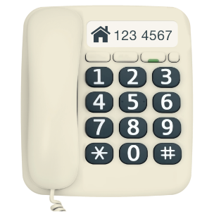 | If you would like to know more, please contact  The Havering Community Learning Disability Team  Main Number: 01708 433446

